A tent is not a home…
But for many people in our community, a tent will be their only means of shelter this summer.
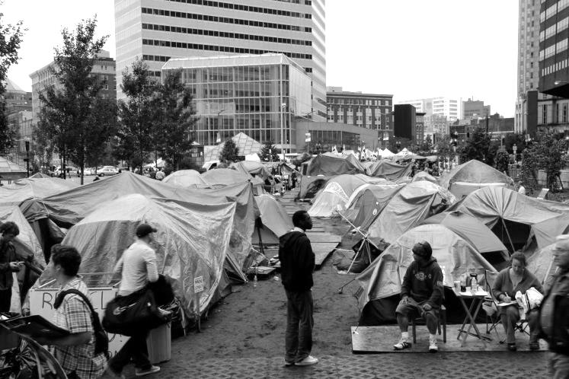

Grace House’s Overflow Shelter season concludes June 28. We will have no alternative shelter to offer when Grace House is full.
If you’re unable to volunteer, consider donating gently used tents and sleeping bags and bring the power of community together.
If you belong to a service club, fraternal organization or church group, please consider sponsoring a tent and sleeping bag drive for those who are turned away from Grace House this summer.
For more information, go to the Sponsor A Drive page on our website www.gracehousemn.org or contact us directly at (218) 326-2790.

